Design Document – DEC Purchase Invoice Approval - POC

Approval Workflow
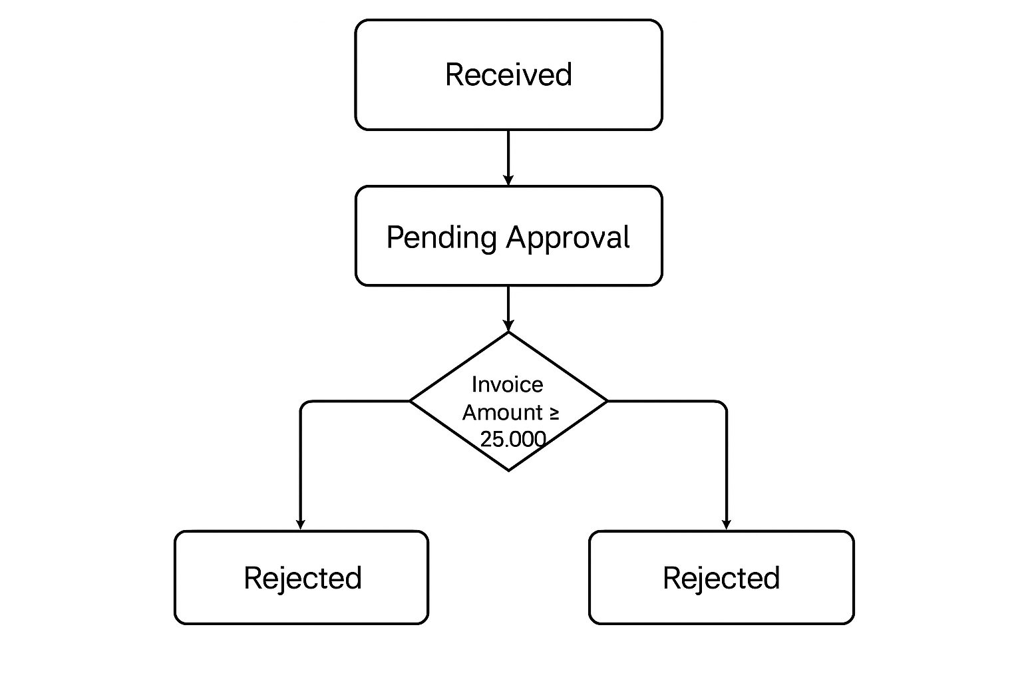

✅ App behaviour by Status
Status | App behaviour
Received | Read-only
Pending Approval | Read-only
Approved | Read-only
Rejected | Editable (Finance only)

